**Class Diagram and ER Diagram Submission**

**Group: 01**

**Group Members:**

Atanu Rudra Joy: 18-38876-3

Arifur Rahman: 18-38852-3

Md Nabil Hossain: 18-38585-2

Abdullah Al Maksud: 18-38582-2

**Submitted to:** Dr. Razib Hayat Khan

**Date of Submission:** November 30, 2020

Class Diagram

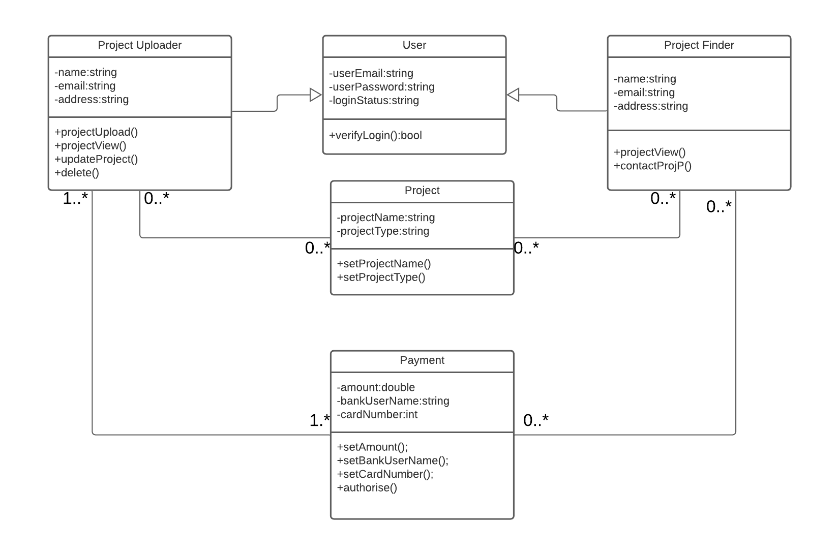

ER Diagram

